Booking System Overbooking – Critical Section & Synchronization Explanation Report

Student Name: Sodaba Davlatzada
ID: 230018

1. The Centrum Air Overbooking Case
In September 2025, Uzbekistan-based airline Centrum Air experienced a real-world overbooking incident on a flight from Istanbul to Namangan. A passenger legally purchased two tickets through the airline’s official website for himself and his spouse. However, due to the airline selling more tickets than available seats (overbooking), the couple was denied boarding on the scheduled flight day.
They were left stranded at Istanbul Airport for one full day. Eventually, the airline offered them an alternative route via an Istanbul–Tashkent flight, which they accepted under the circumstances. Dissatisfied with the inconvenience, disruption, and extra time spent at the airport, the passenger filed a formal complaint with the Namangan Regional Department of the Anti-Monopoly Committee (Competition Committee), claiming a violation of consumer rights.
After investigation, Centrum Air acknowledged the error caused by their overbooking practice. The airline reached a settlement and provided compensation to the affected passengers, including financial payment, additional benefits (such as a promotional discount code for future flights), and other accommodations.
This case clearly demonstrates the serious consequences — financial loss, reputational damage, legal complaints, and passenger dissatisfaction — that can arise when a booking system fails to properly manage shared limited resources (seats) under concurrent access.

2. Critical Section Concept
A critical section is any part of a program where multiple threads or processes access and modify a shared resource (variable, file, database record, etc.). In concurrent programming, this section must be executed in a mutually exclusive way — meaning only one thread at a time is allowed inside it.
If multiple threads enter the critical section simultaneously, they can interfere with each other’s operations, leading to incorrect results, data corruption, or inconsistent program state. This interference is known as a race condition.

In our booking system example:
- The shared resource is the integer variable available_seats.
- The critical section includes:
  - Reading/checking the current value (if available_seats > 0)
  - Modifying it (available_seats -= 1)
Without protection, these two steps are not atomic — other threads can interrupt between them, causing errors.

3. Read/Write Conflict (Race Condition)
A read/write conflict (or race condition) occurs when the outcome of operations depends on the unpredictable timing or interleaving of thread execution.
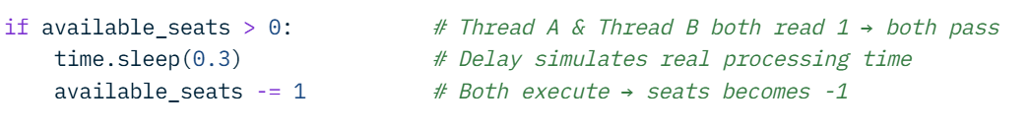
Classic example from the unprotected booking code:

Even though only one seat was available:
- Both threads read the same value (1)
- Both believe a seat is free
- Both decrement → overbooking (sold 2 tickets for 1 seat)
This is a TOCTOU vulnerability (Time-Of-Check to Time-Of-Use): the check and the use are separated in time, allowing interference. In real systems, this leads to selling more tickets/seats than physically exist — exactly as happened in the Centrum Air case.
4. Producer–Consumer Analogy
The seat booking problem can be viewed through the classic Producer–Consumer pattern (bounded buffer problem):
- The buffer = available seats inventory (limited capacity = 5 seats)
- The consumers = customers/threads trying to book (consume) a seat
- The producers = (in this analogy less relevant, but could be seat cancellations adding seats back)
Key issue: multiple consumers trying to take from a nearly empty buffer at the same time.
Without synchronization:
- Several consumers see “seats > 0” almost simultaneously
- They all “consume” → buffer goes negative → more tickets sold than seats exist
With proper synchronization (mutex/semaphore):
- Only one consumer at a time can check and take a seat → prevents underflow/negative values
- Guarantees correctness even with many concurrent requests
This analogy shows why synchronization primitives are essential whenever multiple threads access a limited shared resource.

5. Chosen Solution and Why It Works
Chosen solution: Mutex lock to protect the critical section.
Implementation (simplified):

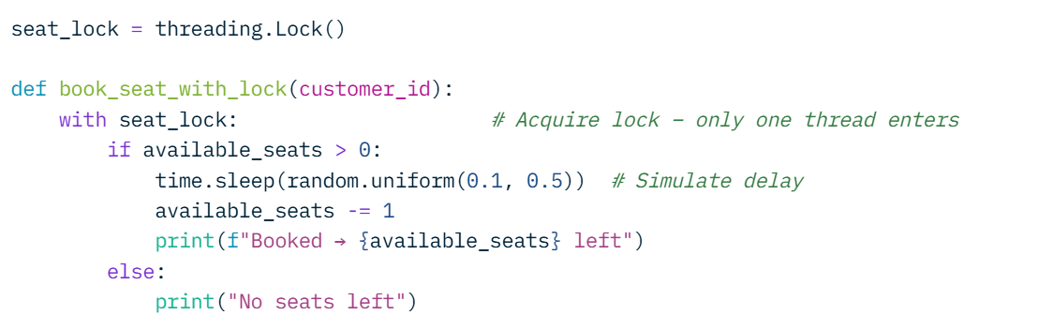

Why it works:
- The with seat_lock: statement ensures mutual exclusion — only one thread can execute the check-and-decrement block at any moment.
- Other threads wait (block) until the lock is released → no interleaving possible inside the critical section.
- The read (check) + write (decrement) become atomic with respect to other booking threads.
- Result: at most 5 successful bookings occur → available_seats never goes below 0 → overbooking is prevented.
Alternatives (e.g. semaphore initialized to 5, or queue.Queue with maxsize) exist, but a simple mutex is the clearest way to protect this exact critical section pattern.
This solution directly addresses the Centrum Air problem: proper synchronization in the backend booking logic would have prevented selling excess tickets, avoiding denied boarding and compensation payments.

Conclusion Concurrent access to shared resources without synchronization leads to subtle but severe bugs (race conditions). The Centrum Air incident illustrates real-world impact. Using mutex locks to guard critical sections is a fundamental, reliable way to ensure correctness in multithreaded systems.

